

**11路**

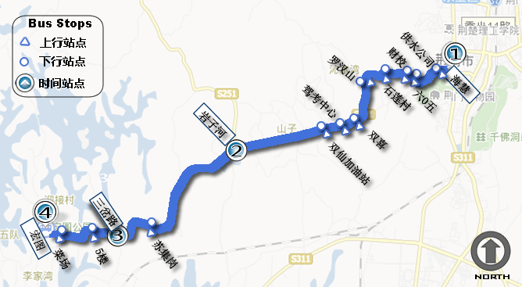

|  |  |  |  |  |  |  |  |  |
| --- | --- | --- | --- | --- | --- | --- | --- | --- |
| 11路Title.png | | | | | | | | |
| 上行：海惠-宏图 单程时间：0:33:26 | | | | | **下行：宏图-海惠 单程时间：0:34:00** | | | |
| 工 作 日 ( 周 一 至 周 五 ) | 5:50:00 | 6:06:23 | 6:15:48 | 6:23:26 | 5:50:00 | 5:58:47 | 6:08:10 | 6:24:00 |
| 6:30:00 | 6:46:23 | 6:55:48 | 7:03:26 | 6:28:00 | 6:36:47 | 6:46:10 | 7:02:00 |
| 7:10:00 | 7:26:23 | 7:35:48 | 7:43:26 | 7:06:00 | 7:14:47 | 7:24:10 | 7:40:00 |
| 7:50:00 | 8:06:23 | 8:15:48 | 8:23:26 | 7:44:00 | 7:52:47 | 8:02:10 | 8:18:00 |
| 8:30:00 | 8:46:23 | 8:55:48 | 9:03:26 | 8:22:00 | 8:30:47 | 8:40:10 | 8:56:00 |
| 9:10:00 | 9:26:23 | 9:35:48 | 9:43:26 | 9:00:00 | 9:08:47 | 9:18:10 | 9:34:00 |
| 9:50:00 | 10:06:23 | 10:15:48 | 10:23:26 | 9:38:00 | 9:46:47 | 9:56:10 | 10:12:00 |
| 10:30:00 | 10:46:23 | 10:55:48 | 11:03:26 | 10:16:00 | 10:24:47 | 10:34:10 | 10:50:00 |
| 11:10:00 | 11:26:23 | 11:35:48 | 11:43:26 | 10:54:00 | 11:02:47 | 11:12:10 | 11:28:00 |
| 11:50:00 | 12:06:23 | 12:15:48 | 12:23:26 | 11:32:00 | 11:40:47 | 11:50:10 | 12:06:00 |
| 12:30:00 | 12:46:23 | 12:55:48 | 13:03:26 | 12:10:00 | 12:18:47 | 12:28:10 | 12:44:00 |
| 13:10:00 | 13:26:23 | 13:35:48 | 13:43:26 | 12:48:00 | 12:56:47 | 13:06:10 | 13:22:00 |
| 13:50:00 | 14:06:23 | 14:15:48 | 14:23:26 | 13:26:00 | 13:34:47 | 13:44:10 | 14:00:00 |
| 14:30:00 | 14:46:23 | 14:55:48 | 15:03:26 | 14:04:00 | 14:12:47 | 14:22:10 | 14:38:00 |
| 15:10:00 | 15:26:23 | 15:35:48 | 15:43:26 | 14:42:00 | 14:50:47 | 15:00:10 | 15:16:00 |
| 15:50:00 | 16:06:23 | 16:15:48 | 16:23:26 | 15:20:00 | 15:28:47 | 15:38:10 | 15:54:00 |
| 16:30:00 | 16:46:23 | 16:55:48 | 17:03:26 | 15:58:00 | 16:06:47 | 16:16:10 | 16:32:00 |
| 17:10:00 | 17:26:23 | 17:35:48 | 17:43:26 | 16:36:00 | 16:44:47 | 16:54:10 | 17:10:00 |
| 17:50:00 | 18:06:23 | 18:15:48 | 18:23:26 | 17:14:00 | 17:22:47 | 17:32:10 | 17:48:00 |
|  |  |  |  | 17:50:00 | 17:58:47 | 18:08:10 | 18:24:00 |



**11路**

|  |  |  |  |  |  |  |  |  |
| --- | --- | --- | --- | --- | --- | --- | --- | --- |
| 11路Title.png | | | | | | | | |
| 上行：海惠-宏图 单程时间：0:34:41 | | | | | **下行：宏图-海惠 单程时间：0:34:34** | | | |
| 周 末 （ 周 六 和 周 日 ） | 5:50:00 | 6:06:58 | 6:16:34 | 6:24:41 | 5:50:00 | 5:58:55 | 6:08:20 | 6:24:34 |
| 6:28:00 | 6:44:58 | 6:54:34 | 7:02:41 | 6:28:00 | 6:36:55 | 6:46:20 | 7:02:34 |
| 7:06:00 | 7:22:58 | 7:32:34 | 7:40:41 | 7:06:00 | 7:14:55 | 7:24:20 | 7:40:34 |
| 7:44:00 | 8:00:58 | 8:10:34 | 8:18:41 | 7:44:00 | 7:52:55 | 8:02:20 | 8:18:34 |
| 8:22:00 | 8:38:58 | 8:48:34 | 8:56:41 | 8:22:00 | 8:30:55 | 8:40:20 | 8:56:34 |
| 9:00:00 | 9:16:58 | 9:26:34 | 9:34:41 | 9:00:00 | 9:08:55 | 9:18:20 | 9:34:34 |
| 9:38:00 | 9:54:58 | 10:04:34 | 10:12:41 | 9:38:00 | 9:46:55 | 9:56:20 | 10:12:34 |
| 10:16:00 | 10:32:58 | 10:42:34 | 10:50:41 | 10:16:00 | 10:24:55 | 10:34:20 | 10:50:34 |
| 10:54:00 | 11:10:58 | 11:20:34 | 11:28:41 | 10:54:00 | 11:02:55 | 11:12:20 | 11:28:34 |
| 11:32:00 | 11:48:58 | 11:58:34 | 12:06:41 | 11:32:00 | 11:40:55 | 11:50:20 | 12:06:34 |
| 12:10:00 | 12:26:58 | 12:36:34 | 12:44:41 | 12:10:00 | 12:18:55 | 12:28:20 | 12:44:34 |
| 12:48:00 | 13:04:58 | 13:14:34 | 13:22:41 | 12:48:00 | 12:56:55 | 13:06:20 | 13:22:34 |
| 13:26:00 | 13:42:58 | 13:52:34 | 14:00:41 | 13:26:00 | 13:34:55 | 13:44:20 | 14:00:34 |
| 14:04:00 | 14:20:58 | 14:30:34 | 14:38:41 | 14:04:00 | 14:12:55 | 14:22:20 | 14:38:34 |
| 14:42:00 | 14:58:58 | 15:08:34 | 15:16:41 | 14:42:00 | 14:50:55 | 15:00:20 | 15:16:34 |
| 15:20:00 | 15:36:58 | 15:46:34 | 15:54:41 | 15:20:00 | 15:28:55 | 15:38:20 | 15:54:34 |
| 15:58:00 | 16:14:58 | 16:24:34 | 16:32:41 | 15:58:00 | 16:06:55 | 16:16:20 | 16:32:34 |
| 16:36:00 | 16:52:58 | 17:02:34 | 17:10:41 | 16:36:00 | 16:44:55 | 16:54:20 | 17:10:34 |
| 17:14:00 | 17:30:58 | 17:40:34 | 17:48:41 | 17:14:00 | 17:22:55 | 17:32:20 | 17:48:34 |
| 17:50:00 | 18:06:58 | 18:16:34 | 18:24:41 | 17:50:00 | 17:58:55 | 18:08:20 | 18:24:34 |